Ideation Phase
Define the Problem Statements

Date | 8 March 2025
Team ID | SWTID1743498710
Project Name | I-Movies : Movie Ticket Booking System
Maximum Marks | 2 Marks
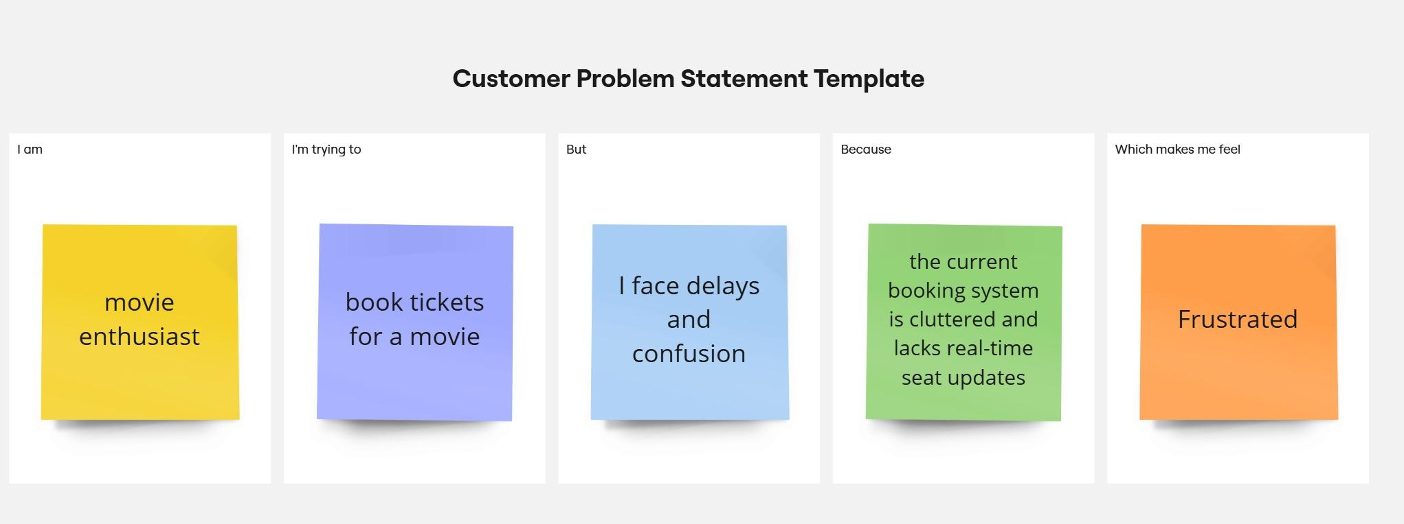

Problem Statement (PS) | I am (Customer) | I’m trying to | But | Because | Which makes me feel
PS-1 | book tickets quickly for a nearby theater | book tickets quickly for a nearby theater | the booking process is slow and cluttered | the platform has too many steps and lacks seat availability updates | frustrated and impatient
PS-2 | a smartphone user | choose and book seats interactively | the seat map doesn’t show real-time availability | the system doesn’t update dynamically | anxious and uncertain about bookings
PS-3 | a new user of the platform | sign up and login securely | I have to manually verify my email every time | there's no seamless login experience | annoyed and discouraged from returning
PS-4 | a user managing group bookings | select multiple seats together | available seats aren’t grouped or marked clearly | the UI doesn’t allow easy selection of multiple adjacent seats | confused and annoyed
PS-5 | a payment-conscious customer | securely complete my ticket payment | I’m unsure if the payment went through | payment feedback is delayed and inconsistent | worried and unconfident

